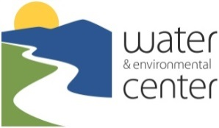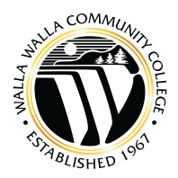

FOR IMMEDIATE RELEASE

Contact: Dave Stockdale
Phone: (509) 524-5193
Email: dave.stockdale@wwcc.edu

TWO free PROGRAMs on March 10: “Water Rights & POLICIES for
AGRICULTURISTS & WINERIES” and “Water Rights & Wells for Rural Homes”

Two free programs on water rights and policies⎯one for rural homeowners and another for agriculturists and wineries⎯will be held at the William A. Grant Water & Environmental Center on the Walla Walla Community College Campus on Thursday, March 10. Both programs will feature presentations by experts from the Washington State Department of Ecology, Walla Walla Watershed Management Partnership, Water Rights Solutions, and the WWCC Water & Environmental Center.

“Water Rights & Policies for Agriculturists & Wineries” will be the focus of the 8:30 am-12:15 pm session. Topics will include: “Water Rights & Exempt Well Policies”; “Managing Your Water Rights”; and, “The New Winery Wastewater Permit Program”. Attendees will have an opportunity to discuss water rights, policies and the wastewater permit program with the presenters during an extended question and answer session. The program will conclude with a presentation on “ASP Composting for Grape Pomace & Other Organic Wastes” by the firm O2Compost, followed by an optional tour of the WWCC grape pomace composting trial.

“Water Rights & Exempt Wells for Rural Homes” will be the focus of the 7-9 pm session. Attendees will have the opportunity to learn the basics about Washington State water rights and domestic wells, with ample time for questions and answers. The intent is to provide clarity for individuals who own a rural home, plan to build, or want to buy, sell or divide land. Attendees will also hear about how new water use is limited in some areas, and learn about opportunities to manage their water rights through programs offered by the Walla Walla Watershed Management Partnership.

# # #

For more information please contact Dave Stockdale, Director of the WWCC Water & Environmental Center, at (509) 524-5193 or dave.stockdale@wwcc.edu, or Chris Hyland, Executive Director of the Walla Walla Watershed Management Partnership, at (509) 524-5217 or chris.hyland@wwcc.edu.

